Name: Sally Phan
Year: 10

Transform a Face into a Powerful text
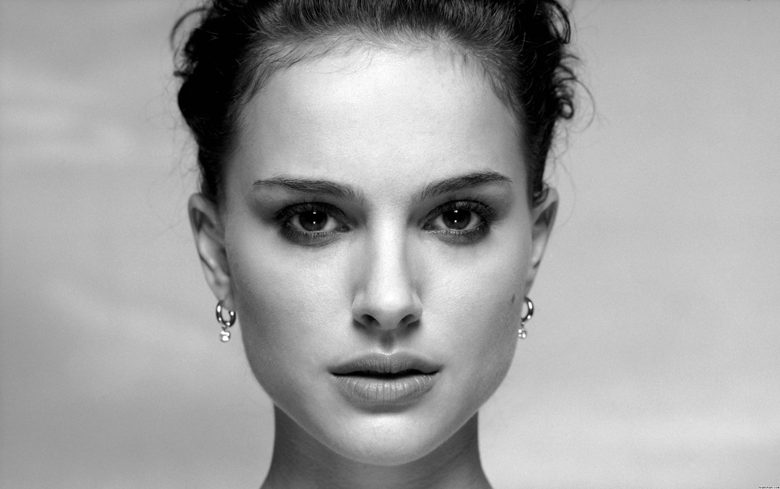

Step 1:

- Opened the model I like to use in Photoshop and made the Displacement Map.
- Click the icon in the right side and click on Duplicate Layer. At the Document click New and typed the is Displacement then Ok.

Step 2:

- Go to the Filter -> Blur -> Gaussian Blur then made the Radius to 4.0 Pixels and Ok.
- Go to File and Save As in to the Desktop with Photoshop (*.PSD;* .PDD) and click save.
- I deleted this this displacement.

Step 3:

- Used the Pencil Tool make it small about 9px and make sure it black, press and click on ….
- Draw around her and then click on Paint Bucket Tool and then fill it in her image.
- Pressed Q and then Command + Shift + I.

Step 4:

- Go to Select and Alt + Command + R. Check Smart Radius and made the Radius about 21px.
- Looked at the Output To click on New Layer with Layer Mask then click Ok.
- Command click on the Layer icon to made the new Layer fill it black by Alt + Delete.

Step 5:
- Opened the Lyrics of any song Command + C.
- Opened the www.word.net and Command + V after I choose Created your own then Go ( make sure you have Java in your computer).
- Click Language and choice Make All Words Upper-Case, click Font and choice Goudy Bookletter 1991, click Layout and choice Straighter Edges and Mostly Horizontal, click color and and choice WB.
- Click open in window and then made it full screen and Shift + Command +3.

Step 6:

- Go to File -> Open then Cmd + A, Cmd + C, go to File -> New then click ok then Cmd + V.
- Select the Rectangular Marquee Tool then select all the black side so do not touch the words. After that Cmd + Shift + I and fill with black Alt + Delete then Cmd + D.
- Click the Channels click the small circle at the bottom to select all the words.
- Come back the Layer and click on the Layer to make the New Layer fill it black again Cmd + Delete and then Cmd + D.

Step 7:

- Cmd + V to move it to the model Layer. Double click on that layer and click Drop Shadow then make the Distance and Size is 5px then click Ok.
- Cmd + T to make the text smaller and move whatever I want then Enter. Made a copy layer Cmd + J doing the same thing just move another place turn some of it 90 degree, keep do it until 12 layer.
- Go down to the layer Shift + click on it to select on the layer then Cmd + G to make it become a group.

Step 8:

- Made a copy of a folder Cmd + J and go to Edit -> Transform -> Rotate 90 degree Counter Clockwise then move it.
- Made another copy and move it another place keep doing it until full her face. Let’s group it again by Shift + click on it and Cmd + G.
- Cmd + T and then Cmd + 0 to see the transform in tiny place. Make the text become smaller and move it in ¼ her face.
- Make another copy and move it to the right of her face so I got 2/4 her face. Keep do it until it full her face Then Cmd + 0.

Step 9:

- Shift + click on the layer and then go to the small icon at the right corner click on it and choice Convert To Smart Object.
- Go to Filter -> Distort -> Displace, Horizontal and Vertical Scale should be 10 then click Ok.
- Click the Displacement folder and click open. Click off the layer of the text to hide the layer.
- Click on the face layer to make it active then Cmd + Shift + Alt + E to make the new layer.

Step 10:

- Hide the layer with the layer mask then put the layer copy to the top the text layer.
- Change Normal to Linear Burn and make the text available. Click the adjustment icon and click on Levels -> Light it about 200.

Step 11:

- Save it in JPG.

Here we go:

